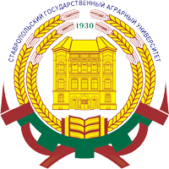
STAVROPOL STATE AGRARIAN UNIVERSITY

Faculty of Accounting and Finance
Faculty of Economics

IV INTERNATIONAL CONFERENCE
“MODERN PROBLEMS OF NATIONAL ECONOMIC DEVELOPMENT”

May 24-25, 2012

Conference sections:
- Contemporary macroeconomic issues
- Modern features of economic development
- Problems and outlook for financial sector development in modern conditions of national economy
- Opportunities for innovative development of global economy
- Management: modern development tendencies
- Information technologies in economics
- Socio-economic and legal problems of market economy, ways of solution
- Sustainable development on macro- and micro levels
- Accounting: development tendencies in the conditions of economic globalization
- Audit: theory and practice of application in modern economy

Deadline for papers submission: May 10th, 2012.

Please forward your papers to Dr. Vasily Erokhin, Head of IRO, e-mail: stavropolfad@yandex.ru

Publication is free of charge
for SSAU partner universities

