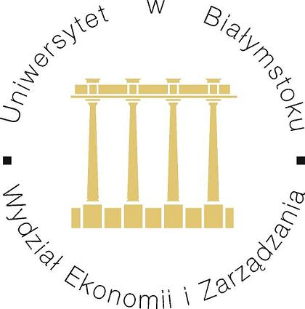
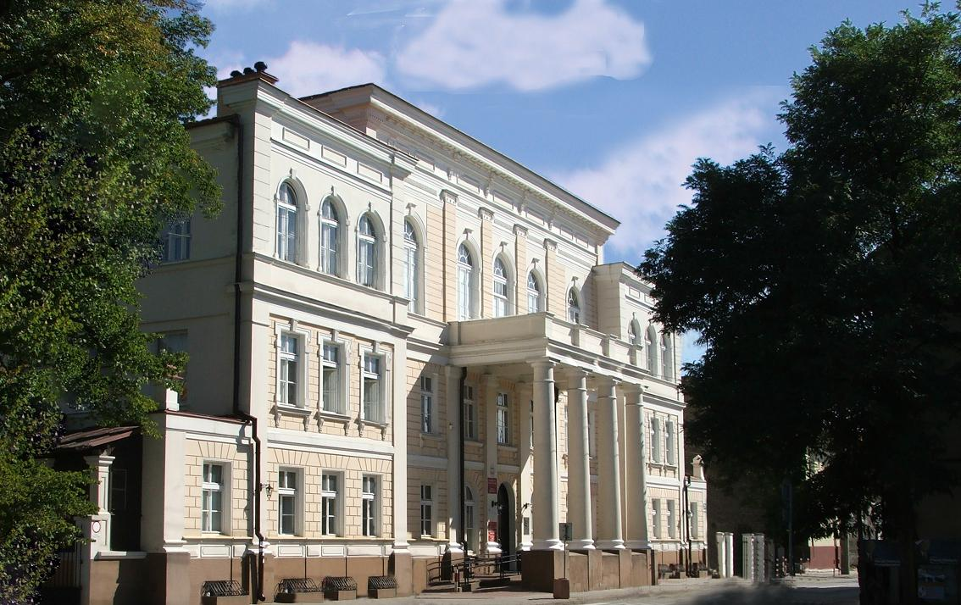

XIX CONGRESS

The Polish Association of Agricultural
and Agribusiness Economists

Rural Areas and Agribusiness
in Changing Economic Situation

Bialystok, September 05-07th 2012
Dear Sir/Madam!
We want invite you to take a part in the XIX Congress
of The Polish Association of Agriculture and Agribusiness Economists
which will organized in Bialystok from September 05th to 07th 2012

The topic of the Congress:

„Rural Areas and Agribusiness
in Changing Economic Situation

During the Congress six sessions are planed. The subject of these session are as follows:

- Changing economic situation and agribusiness development
- EU agriculture policy in new multiannual financial framework
- State policy and rural areas development
- Problems of peripheral regions functioning
- Environmental protection and development of rural areas and agribusiness
- The English session

The Congress fee has been set as follow:

- Full participation (including excursion within Poland) | 1200 zł
- Full participation (including excursion outside Poland) | 1300 zł
- Participation excluding excursion | 1050 zł
- Participation without publication (including excursion outside Poland) | 1000 zł
- Participation without publication (including excursion within Poland) | 900 zł
- Fee for one publication (without participation) | 550 zł

Within the first, second and third variant - participants will receive digitally version of the Congress materials and one copy of materials, in which author’s article was published. Participants choosing the fourth and fifth variant will receive digitally version of the Congress materials. Variant sixth entitles to receive materials, in which author’s article was published (it will by send by post).
The participation costs concern papers not longer than 6 pages prepared according to the editor requirements (annex). Additional payment will be required if the paper is longer: 50 PLN for the seventh (7th) page and 200 PLN for each next one (additional fee does not apply to articles commissioned).
Because of the late hour of return from excursion outside Poland there is a possibility to reserve additional accommodation on September 7th (cost 50 zł per bed). Additional fee should be paid on a place of accommodation.

The ruled of resignation from the participation in the Congress SERiA:
1. The decision of resignation from participation in Congress SERIA should be noticed on the address: sekretariat@seria.home.pl and to the Congress Committee organizers to July 31st 2012. After this data payments will not be returned.
2. In the case of the total resignation from participation in the Congress before the definite date described in point 1 and not notificated article to the publication in the established deadline the manipulative payment 100 PLN will be deducted.
3. In the case of the total resignation from participation in the Congress before the definite date described in point 1 and not-accepted the article to the publication the manipulative payment 200 PLN will be deducted.
4. In case of the variant change of participation in the Congress before the definite date in point 1 the manipulative payment is not deducted.
5. The manipulative payment is not charged and definite deadline in the point 1 is not valid in the case of earlier notified by participant. These changes should be noticed the latest on seven days before beginning to the Congress Committee

During the Congress Organizers offer selected excursions. Suggested routers and programs of those excursions are as follows:
Route no. 1 – Vilnius and rural areas of Vilnius Country – the past, the present time and the future (with guide).
Route no. 2 – Land being famous for a milk and honey – dairy households, Dairy Cooperative Mlekowita, apiarian household, Polmos - vodka producers (with guide).
Route no. 3 – EU Rural peripheral areas – The Tartar trail, the farming and the agribusiness on rural peripheral areas (with guide).

We kindly request to Mark on registration form which route you would like to choose.
In case of little interest in any of the above mentioned excursions The Organization Committee reserves the right to make changes, after consultation with participants.

To join the XIX Congress please complete registration form, which is on SERiA web side http://www.seria.home.pl/index.php?option=com_content&task=view&id=315&Itemid=82
by the February 28th 2012.

XIX SERiA Congress Committee
University of Bialystok
Faculty of Economics and Management
Department of Entrepreneurship
ul. Warszawska 63, 15-062 Bialystok
e-mail: awyszkowski@op.pl

The Congress fee should be paid by May 31st 2012 to the following bank account:
Stowarzyszenie Ekonomistów Rolnictwa i Agrobiznesu
ul. Wojska Polskiego 28, 60-637 Poznań
PKO BP S.A. 39 1020 4027 0000 1902 0439 5521
IBAN: PL
SWIFT: BPKOPLPW

In the title of bank transfer should be written: "XIX Kongres" and the full name of a person the payment is done for.
The contact persons, if you need any further information:
dr Adam Wyszkowski  Sekretarz  Uniwersytet w Białymstoku  Wydział Ekonomii i Zarządzania  Katedra Skarbowości  ul. Warszawska 63, 15-062 Białystok  tel. 85 745 77 02, fax 85 745 77 02  e-mail: awyszkowski@op.pl | dr hab. Adam Sadowski  Przewodniczący  Uniwersytet w Białymstoku  Wydział Ekonomii i Zarządzania  Zakład Przedsiębiorczości  ul. Warszawska 63, 15-062 Białystok  tel. 85 745 77 06, 607 377 097  e-mail: adamsad@poczta.onet.pl

According to the SERiA Board the papers with the statement of originality (requirements for paper preparation and statement form are enclosed below and published on web side www.seria.home.pl) should be send directly to Scientific Annals Editor SERiA - in electronic form to e-mail address: biurowj@op.pl.
Persons that do not have internet access should send papers (floppy disc or CD/DVD and printed version) by post to:
Wydawnictwo Wieś Jutra
ul. Bruzdowa 112F
02-991 Warszawa
tel. 22 643 82 60

The papers should be sent by April 10th 2012

Detailed information about the XIX Congress and registration forms to complete can be obtained from SERiA website: www.seria.home.pl.
Secretary's office of the Congress tel. +48 85 745 77 02 (06), +48 607 377 097

For those who are interested there are possibility to extend stay in Bialystok to September 9th 2012 (Persons individually cover overnight costs 50 PLN/person). Additional fee should be paid on a place of accommodation.

Chairman of the Organizing Committee

XIX Congress SERiA

dr hab. Adam Sadowski

